# **INTRODUCTION**

The Judicial System of the United States consists of courts at various levels. Most prominent is the Federal Court System, which resolves cases at either the Trial Court (or District Court) level, Circuit Court or Supreme Court, depending on the facts of the cases, level of jurisdiction and right of appeal. In the United states, each state has a fully functioning court system that runs in parallel to the Federal Court system.

A vast majority of civil and criminal cases within the United States are resolved through the State Court system. Back in 2006, a record high total of 102 million cases newly filed, reopened, and reactivated cases reported to the Bureau of Justice Statistics’ Court Statistics Project (CSP) were filed in state courts all over the country. More than 50% of these cases fall arise from traffic violations, and these cases can be resource intensive for the courts to process and adjudicate. In previous years, when the number of cases increased without a corresponding increase in the number of judicial officers working on those cases, the number of cases that needed to be resolved increased by up to 5%. This puts a strain on the court systems of various states within the United States.

Civil and criminal cases within state courts typically run in a few key stages (1) arraignment, or arrest of the person charged within the crime (2) case setting, that involves prosecutors laying out the facts of the case and identifying the charges on which the case will be contested (3) trial or plea bargaining, as the case may be and (4) case resolution, verdict and sentencing.

While a large number of cases are filed every year for serious crimes that are expected to result in harsher punishments, many cases that are filed in state courts within the United States often involve lower level crimes that are not serious enough to merit a prison sentence longer than a year. Hence, a large number of people that are charged with crimes are not detained in prison during the various stages of the case. This ensures that persons are detained in jails only if required, and keeping in mind the capacity of jails themselves to house a certain number of persons.

Between 1990 and 2004, 62% of felony defendants in State courts in the 75 largest counties within the United States were released prior to the disposition of their case. Starting in 1998, financial pretrial releases, requiring the posting of a bail amount, were more prevalent than non-financial releases. Among defendants detained until case disposition, 1 in 6 had been denied bail and 5 in 6 had bail set with financial conditions required for release that were not met. Bail amounts were set to be higher for more serious crimes, or for cases where there was prior criminal history, with murder defendants being least likely to be released pretrial.

In order for the court system to function smoothly in terms of resolving cases, it is important that defendants that are released before trial return to the courthouse for subsequent hearings whenever they are summoned. Failure of a defendant to appear before a judge is highly problematic in carrying on with case hearings as scheduled, and may result in worse outcomes for such defendants in the cases itself. This often leads to postponement in hearings. In court systems that have limited resources and rising caseloads, it is important that cases can be resolved to completion as quickly as is possible.

The King County Prosecuting Attorney’s office is one such court that experiences the problem of cases being delayed due to defendants failing to appear before a judge, resulting in cases taking longer to be completed to resolution. There is limited knowledge available in terms of how difficult the situation is in various courts within the United States.

Hence, this project is an effort in quantifying the situation. The goal of this exercise is to identify possible causes for cases being delayed in courts, and to find out ways in which those root causes can be addressed moving forward.

# **LITERATURE REVIEW**

The resolution of cases in courts of all levels is delayed for many possible reasons, one of which involves defendants failing to appear before a judge. The King County Prosecuting Attorney is one such court that faces this problem and wants to use data from past cases to identify potential solutions to this problem. To do so, this paper will address the question of what factors affect the rate at which defendants fail to appear, and these findings could be used to identify actions that could be taken to address this issue.

As per American Economic Review 2018, over 20 percent of prison and jail inmates are currently awaiting trial in the United States. The reported examined who is likely to get pretrial release and how much defendants need to pay for the same. It also highlights the impact of pretrial release on defendants in the future; i.e. what are the chances of a defendant committing a crime in the future, and what is the probability of employment. The court data used for this study is from Philadelphia (Pennsylvania court of common and Philadelphia municipal court between 2007-2014) and Miami-Dade (2006-2014) merged to tax data from the Internal Revenue Service (IRS). So, the study result may not be applicable to entire USA or other countries.

This report found that pretrial detention significantly increases the probability of conviction primary through the increase in guilty plea. There are no records which shows the increase in criminal activity among pretrial detained defendants but it surely decreasing the employment chances in formal sectors and the receipt of employment tax related government benefits. The main reason is that a criminal conviction lowers the defendant’s prospect in formal labor market.

Not every defendant is treated same for pretrial release. Murder defendants were the least likely to be released pre-trial. Defendants charged with rape, robbery, burglary, and motor vehicle theft also has low rate of detention than average. Defendants charged with fraud are the most likely to released. But defendants with prior criminal records are less likely to be released than those without.

There are different types of bail in USA. Financial bail was the most common one in year of 1998 where 7 out of 10 defendants used to get it because bail amount was less than $5000 but this proportion dropped to 1 out of 10 when bail was set to $100,000. Bail amount was revised because of less DFA among released defendants. So, the higher the bail amount the lower the probability of pretrial release. As per the result, we found that defendants with violent offenses or had a criminal record have a high bail amount or denied bail. Demographics characteristics also effect the release, Hispanics were less likely to be released than non-Hispanic and Males were less likely than females. These pretrial releases bring out another discussion of missing hearings (DFA). Defendants on financial release were more likely to make all scheduled court appearances as compared to ones released on an unsecured bond. Also, rate of missing hearings is high among black or Hispanic defendants, had an active criminal justice.

A special report published by the Bureau of Justice Statistics in November 2007 highlighted the trend at which defendants were released before trial. It also examined the impact of demographic and case related factors on outcomes concerning pretrial release. At the state level, it found that pretrial release of defendants slightly dropped over time, with defendants more often needing to furnish bail through instruments like surety bonds. The bureau also found that defendants on financial release were more likely to follow through on future court appearances than others, while being less likely to be rearrested and charged with misconduct before trial. One out of every four defendants that failed to appear were found to be fugitives after 1 year, with those furnishing surety bonds least likely among all to be fugitives. The data used pertained to cases between 1990 and 2004 in large counties within the US.

Dobbie, Goldin and Yang (2018) analyzed the impact of pretrial detention on outcomes for defendants during and after trials. They found that detention prior to trial, as well as release with financial conditions, did not have a significant effect on future crime, while increasing the likelihood of convictions on account of defendants pleading guilty due to their weaker bargaining positions. There is very little other literature in the public domain dealing with a data driven analysis of factors driving defendant failure to appear.

The above mentioned sources both state that demographic factors are closely related to defendant outcomes. However, the King County Courthouse, like other courts in large counties in the United States has measures in place to deal with defendants that turn into fugitives or engage in crimes that require rearrest.

Pretrial release is a big point of discussion in court houses. It is in discussion because of different impacts and biases in the system. No doubt, pretrial release significantly decreases the probability of conviction, primarily through a decrease in guilty pleas but it also increases the pretrial crimes and missed hearing dates. Previous research has also found that pretrial release increases formal sector attachment both through an increase in formal sector employment and the receipt of tax- and employment-related government benefits.

Since the end goal is to reduce the time taken for a case to be completed in court, this paper will seek to address why defendants fail to appear in court. We will also address what factors affect the time to disposition of a case. Finally, we will examine the relationship between failure to appear in court and outcomes of the case for the defendant. Based on the data available, we will seek to identify patterns in the circumstances that result in defendants failing to appear. Understanding why this happens will allow us to arrive at potential measures that the King County Courthouse can take to deal with defendants that fail to appear in court.

# **DATA**

Data used in this project comes from records maintained by the King County Courthouse of cases running over a period of multiple years. This data was made available to us thanks to the King County Prosecuting Attorney’s Office (hereafter referred to as PAO). Records were compiled manually by representatives from the King County courts at each stage of a case, tracking arraignment, case setting, trial, failure to appear, transfer of defendants into and out of custody as well as previous history of criminal activity.

Each case is entered into the system whenever one is brought to the court following arraignment of the defendant. Defendants range from juvenile defendants to those that are over the age of 60. Cases are classified in various ways based on the events associated with the crime. There may be more than one charge associated with an individual defendant in a case and hence charges are compiled separately. Cases may either be heard in the Seattle Courthouse, if they are brought to the Courts from the northern half of King County, and are heard at the Kent Courthouse if they come from the southern half of the county. A single case is associated with one defendant only, and hence does not represent a single crime.

Every event associated with a case is recorded separately, through manual entry by representatives of the King County Court System. The key event that is important to this study is that of failure of the defendant to appear before a judge and is indicated using specific event codes. Some of these cases go to a drug court, and hence this log of events may include transfers to such courts when they take place. Cases that go to a drug court take longer time to disposition; and hence that is something we have considered in our study of disposition time.

The representatives at the court also record whether defendants are present in custody or have been released on bail, throughout the course of a case. This information is incomplete though, and hence we have made use of certain assumptions in identifying if a defendant may have been in or out of custody, in consultation with the PAO.

All charges associated with a defendant are recorded by the Court. Records indicate that this information may change over time, as initial information about the case is recorded by police officers at the time of arraignment and may thereafter be corrected as more information is obtained prior to case setting stage. The Court also records whether enhancements have been made to charges.

Each charge made towards a defendant is classified in a few ways. Charges are classified based on the terms of imprisonment associated with a conviction, and further classified as felonies or misdemeanours, if such terms are greater than a year or not. Charges are also classified as violent and non-violent charges, and are allotted a seriousness score to compare better against other similar charges.

Cases end in one of 4 ways – trial by jury, trial by a bench, plea deals or dismissal of the case. The Court has also recorded information about past criminal history associated with defendants. Some studies indicate that persons with out of state history have higher rates of FTA and recidivism.

# **MODELS AND RESULTS**

## **Disposition time**

The exploratory analysis we have done with the help of the available data gives us a fair idea of how long cases take to be completed. We also now know how the time to disposition, i.e. the amount of time it takes for a case to enter and leave the court system through resolution, differs based on defendant profile, charges and events taking place as part of the case.

### Regression Based Methods

In order for us to determine how well different variables determine disposition time, we decided upon using linear regression, based on the following variables:

* Age: Cases may differ in terms of how long they take to disposition, based on the age group of the defendant, especially those that are minors, or are senior citizens
  + There may be a non-linear relationship between age and disposition time
* Gender: Cases may take longer to be resolved for female defendants than for male defendants
* Criminal history: we can expect cases involving defendants with past criminal history to take longer to reach disposition than with other cases
* Charge type and seriousness: Cases involving more serious charges may take longer to resolve
  + Seriousness is a subjective measure assigned by the court for the case, and hence we could also classify seriousness values into buckets instead
* Events in the case:
  + Cases with trial setting events may take longer to disposition
  + Cases with competency hearings may take shorter time to disposition due to the possibility of the defendant not being mentally sound enough to stand trial
* Drug related cases: Not all cases involving drug charges (under the Uniform Controlled Substances Act) go to drug court, and so we identify cases based on whether there was a drug charge or if it went to drug court, or both

Using disposition time based on filing date, we have found that cases take on average 1 day longer to disposition if the age of the defendant was increased by 2 years. Cases involving juvenile defendants took 14.5 days longer on average, while those involving defendants older than 60 years old took 10.6 days longer. The estimates for age of the defendant is statistically significant at the 1% level, while the estimate for the variable identifying juvenile defendants is statistically significant at the 5% level. However, the variable identifying defendants that are 60 years or older is not statistically significant, indicating that there is not enough evidence that the age threshold of 60 years has an impact on disposition time.

On the other hand, cases involving male defendants take 19.1 fewer days to disposition than female defendants, while cases involving defendants with prior criminal history take 35.9 fewer days to disposition. The estimates for gender and criminal history are both statistically significant, as are variables identifying cases involving a Class A, B or C charge respectively. Cases involving Class A charges take 146.5 days longer to disposition in comparison to misdemeanors, while those involving Class B and C charges take 28.6 and 12.0 days to disposition respectively.

We also find that cases that involve a trial set hearing take an estimated 112.8 days longer to disposition than other cases, while those cases that involve a competency hearing take an estimated 103.5 days to disposition. The latter seems a bit surprising given that such a hearing usually takes place when there are doubts raised about the defendant’s suitability to stand trial for the case. These estimates are statistically significant at the 1% level of significance.

Cases that go to drug court are found to take an average of 265.0 days longer to disposition than other types of cases. We have also identified cases based on whether they have an associated drug charge and found that the estimate of 2.5 days longer to disposition is not statistically significant. This finding seems surprising, but it’s possible that cases involving a drug charge will also involve other charges, possibly more serious ones, and hence the variables identifying charge class explain the variation in disposition time better.

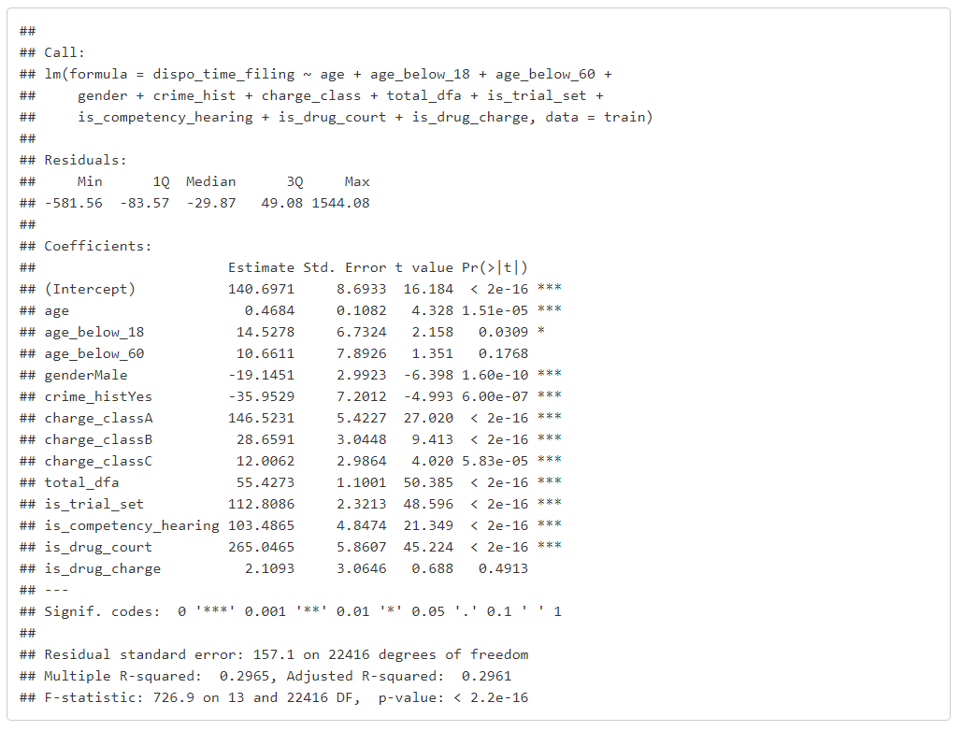

Another variable we considered in our model was the seriousness of the crime, which is a numerical rating indicating how severe the offence involved in the case is. The estimate of 11.5 more days to disposition for every 1 point increase in seriousness is statistically significant at the 1% level. However, while a higher value of seriousness is reflective of the facts of the case, it is still a subjective rating; and cases with similar ratings that are close may involve offenses that are not too different in severity. Hence, we think that charge class better explains the variation in disposition time due to different charge classes including crimes that are quite different from each other in severity of offence. Moreover, it shows us that a case going to drug court has a bigger impact on disposition time than if a case simply involves a drug charge under the Uniform Controlled Substances Act.

### Tree Based Methods

Regression models are simple methods used to identify relationships different variables have with a single dependent variable, as well as to make predictions of future unknown values of the same variable. They are among the most widely used statistical tools that are deployed to answer such questions with the help of data. Hence, they are often considered as a useful benchmark for identifying what technique best explains relationships present in data.

In order to understand how appropriate linear regression is in explaining the relationships variables have with disposition time, we decided to make use of tree models and compare how well they perform in terms of highlighting relationships, as well as using performance measures like Mean Absolute Error (MAE) and Mean Absolute Percentage Error (MAPE). Decision Trees are eager learners that are commonly to build models explaining relationships with a binary dependent variable; however, since disposition time is an quantitative variable, we will be using a Regression Tree. Regression Trees are similar to decision trees, except (here) that is predicts the mean value of disposition time based on the values of different independent variables.

The Regression Tree shown below has 6 terminal nodes with associated values of mean disposition time for a case. Here, we see that the most important factor separating cases is whether the case goes to drug court or not. Cases that go to drug court result in a mean disposition time of 510.4 days, roughly 1 ½ years. Among cases that do not go to the drug court, the most important factor determining disposition time is based on whether there is a trial set event during the case.

It turns out that the time to disposition is much shorter when there is no trial set event than when there is at least one such event during a case. Among such cases, average disposition time for cases where there is at least 1 instance of defendant failing to appear before a judge in court is 221.6 days, as against that of 123.8 days for defendants that always show up in court on the appointed dates.

Among cases where there is a trial set event, however, the time to disposition for a case is longer for crimes that have a higher seriousness score. Cases with a seriousness score greater than 9.5 have an average disposition time of 487.8 days. On the other hand, when the seriousness score of a case is lower than 9.5, we find that cases with at least one instance of failure to appear take 342.7 days to disposition, nearly a full year. Cases with no instances of failure to appear have an average disposition time of 235.3 days.

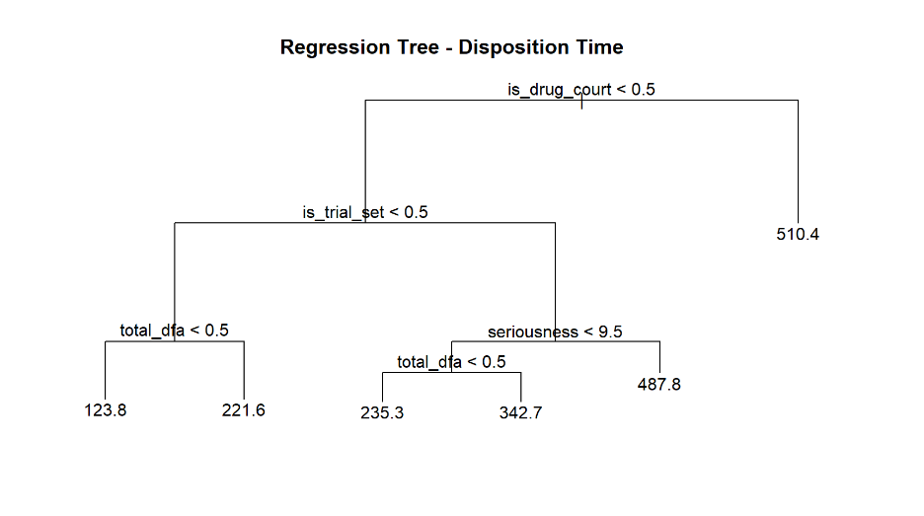

The Regression Tree we have arrived at has a Mean Absolute Error (MAE) of 99.58 and a Mean Absolute Percentage Error of 0.82. This means that the error in prediction of disposition time is roughly 99 days, approximately 47% of the mean disposition time for cases at 211.7 days. The linear regression model that we have selected here compares slightly more favorably, with a corresponding MAE of 96.87 and a MAPE of 0.78.

However, we can also see that the Regression Tree tells us that there are certain variables that clearly differentiate certain cases from others in terms of disposition time. This makes intuitive sense as well – it seems reasonable to expect cases to take longer when they go to drug court, when they involve more serious crimes that have a higher seriousness score attached to them, when they have trial setting events, or when they have at least one instance of a defendant failing to appear before the judge. On the other hand, the linear regression model we have selected tells us that age, gender and past criminal history also explain variation in decision time.

These variables clearly point out the defined characteristic traits of individual defendants can be linked to how long it takes for a defendant to reach completion. However, we do not have any further data available that tells us whether they cause shorter or longer disposition time. Hence, while linear regression performs slightly better based on common performance measures, we see that tree based methods help us identify which variables are more important in terms of their impact on time it takes for a case to reach disposition.